Proposal for ISP

**Name:** Contagion: Bus Conductor

**Genre:** More of a 2D game, top down, puzzle/driving game

**Demographic:** Family Friendly, aimed at younger audience (12 - 16).  
**Idea:**

You are a bus driver, and have gotten orders to enforce physical distancing regulations. As you go through your daily routine on the 94A route, you must pick up passengers and safely distance them.

The game is going to be a grid-based puzzle. These passengers will have certain attributes that affect distancing differently. For example, an elderly person would need to be distanced differently than a healthy young adult, or people with physical disabilities take priority seating over normal people. Everyone *must have empty surrounding sides.*

**Table of current attribute ideas (subject to changes)**

|  |  |
| --- | --- |
| Attribute | Functions in the game |
| Young Adult | Single blocked. No gimmicks. |
| Child + Parent | Single blocked. Same color/shape must stick together. |
| Student | Double-blocked. Takes up an extra block on the side they’re facing. |
| Elderly | Single blocked. Must sit in a blue seat. Diagonal must be empty. |
| Pregnant | Must sit in any seat. Cannot stand. |
| Disabled | Multi-blocked, can occupy blue seats and standing spaces. |
| Grouped | Multi-blocked, must stick together. Consists of any attribute passengers. |
| Large Luggage | Multi-blocked, must stick together. Consists of one attribute passenger. Extra blocks are taken up on the floor or seats. |

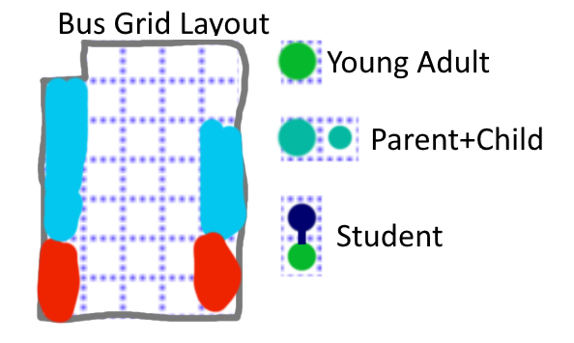

*A small example of the layout, the user must fit all of the passengers into the bus while distancing.*

To get from stop to stop, you actually have to drive the bus along its route. Keep in mind that you must follow the basic driving rules such as: stopping at red lights, staying on the road, not crashing into other cars, etc.

**Facts (based off of):** <https://toronto.ctvnews.ca/ttc-bus-drivers-told-by-union-to-limit-number-of-passengers-to-15-amid-covid-19-pandemic-1.4880116>  
“While the TTC has added buses to some busy routes, we think TTC management should be doing more to enforce physical distancing on the TTC,” Santos said in the memo to members. “For this reason, we are asking members to use their discretion by enforcing these passenger limits during the pandemic. It is important to know *public transit is not exempt from physical distancing regulations.*”

<http://www.ttc.ca/Routes/94/RouteDescription.jsp?tabName=map>

Main game route for the bus (94A)